**-- Top 10 batsmen per season + averages + strike rates**

select season, striker, runs_in_season,runs_in_season/times_out_in_szn as batting_average,

runs_in_season*100/balls_faced_in_szn as strike_rate,

rnk_in_szn

from(

select season,striker,sum(runs_off_bat) as runs_in_season,

sum(case when wides is null and noballs is null then 1 else 0 end) as balls_faced_in_szn,

sum(case when player_dismissed = striker or player_dismissed = non_striker then 1 else 0 end) as times_out_in_szn,

rank() over (partition by season order by sum(runs_off_bat) desc) as rnk_in_szn

from deliveries

group by 1,2) a

where rnk_in_szn <=10

order by season, rnk_in_szn;

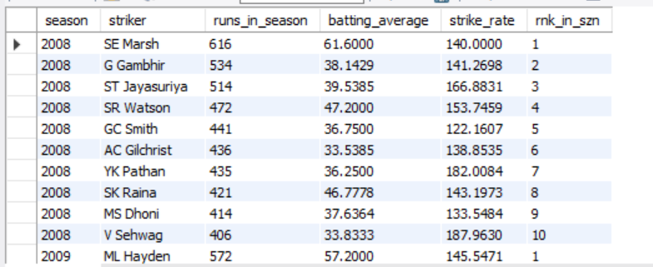

**-- Top 10 bowlers per season + bowling averages + economy rates**

select season, bowler, wickets_in_szn,deliveries_in_szn/wickets_in_szn as bowling_average,

(runs_szn+extras_szn)*6/deliveries_in_szn as economy_rate_szn,

rnk_in_szn

from(

select season,bowler,

sum(case when wicket_type not in ('','run out','retired hurt', 'retired out','obstructing the field')

then 1 else 0 end) as wickets_in_szn,

count(ball) as deliveries_in_szn,

sum(runs_off_bat) as runs_szn,

sum(extras) as extras_szn,

rank() over (partition by season order by sum(case when wicket_type not in

('','run out','retired hurt', 'retired out','obstructing the field') then 1 else 0 end) desc)

as rnk_in_szn

from deliveries

group by 1,2) a

where rnk_in_szn <=10

order by season, rnk_in_szn;

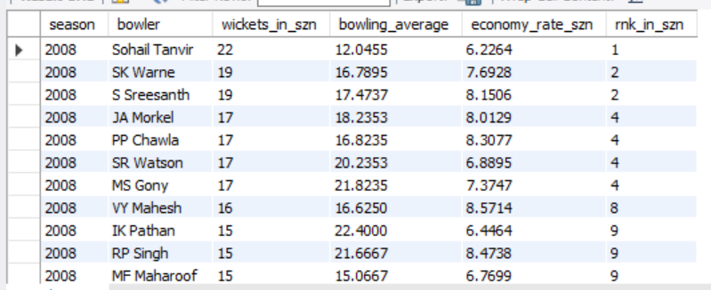

**-- Top 5 batsmen per season based on combined metric**

select *

from (

select a.season,a.striker,round(((runs_in_season/season_average)+(batting_average/season_batting_average)

+(strike_rate/season_strike_rate)),2) as batting_metric,balls_faced,

rank() over (partition by season order by ((runs_in_season/season_average)+(batting_average/season_batting_average)

+(strike_rate/season_strike_rate)) desc) as szn_rnk

from

(select season,striker,sum(runs_off_bat) as runs_in_season,

sum(runs_off_bat)/sum(case when player_dismissed = striker or player_dismissed = non_striker then 1 else 0 end) as batting_average,

sum(runs_off_bat)*100/sum(case when wides is null and noballs is null then 1 else 0 end) as strike_rate,

sum(case when wides is null and noballs is null then 1 else 0 end) as balls_faced

from deliveries

group by 1,2) a

left join

(select season,sum(runs_off_bat) as total_runs_in_season,

sum(runs_off_bat)/count(distinct striker) as season_average,

sum(runs_off_bat)/sum(case when player_dismissed = striker or player_dismissed = non_striker then 1 else 0 end) as season_batting_average,

sum(runs_off_bat)*100/sum(case when wides is null and noballs is null then 1 else 0 end) as season_strike_rate

from deliveries

group by 1) b

on a.season = b.season

where balls_faced>120

) c

where szn_rnk <=5;

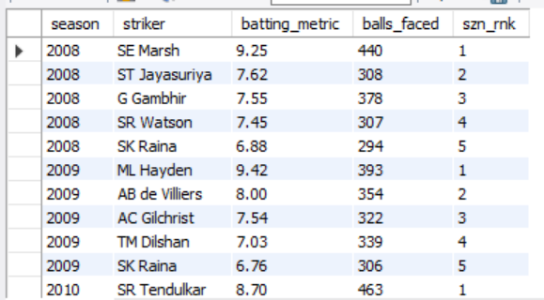

**-- Top 5 bowlers per season based on combined metric**

select *

from (

select a.season,a.bowler,round(((wickets/total_avg_wickets)+(total_bowling_average/bowling_average)

+(total_economy_rate/economy_rate)),2) as bowling_metric,balls_bowled,

rank() over (partition by season order by ((wickets/total_avg_wickets)+(total_bowling_average/bowling_average)

+(total_economy_rate/economy_rate)) desc) as szn_rnk

from(

select season,bowler,

sum(case when wicket_type not in ('','run out','retired hurt', 'retired out','obstructing the field')

then 1 else 0 end) as wickets,

count(ball)/sum(case when wicket_type not in ('','run out','retired hurt', 'retired out','obstructing the field')

then 1 else 0 end) as bowling_average,

count(ball) as balls_bowled,

sum(runs_off_bat+extras)*6/count(ball) as economy_rate

from deliveries

group by 1,2) a

left join

(select season,

sum(case when wicket_type not in ('','run out','retired hurt', 'retired out','obstructing the field')

then 1 else 0 end)/count(distinct bowler) as total_avg_wickets,

count(ball)/sum(case when wicket_type not in ('','run out','retired hurt', 'retired out','obstructing the field')

then 1 else 0 end) as total_bowling_average,

sum(runs_off_bat+extras)*6/count(ball) as total_economy_rate

from deliveries

group by 1) b

on a.season = b.season

where balls_bowled>120) c

where szn_rnk <=5;

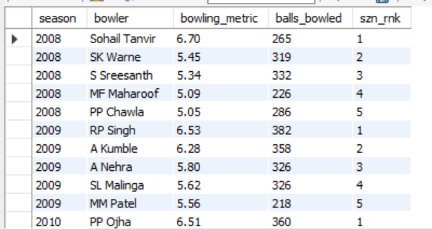

**-- Toss Outcome vs Match Outcome by Venue**

select city,toss_decision,num_matches,win_count_toss_winner/num_matches as win_percent_toss_winner

from(

select city,toss_decision,

sum(case when toss_winner = winner then 1 else 0 end) as win_count_toss_winner,

count(*) as num_matches

from match_details md

left join venue vn

on md.venueID = vn.id

group by 1,2) a

where num_matches > 20

order by 4 desc;

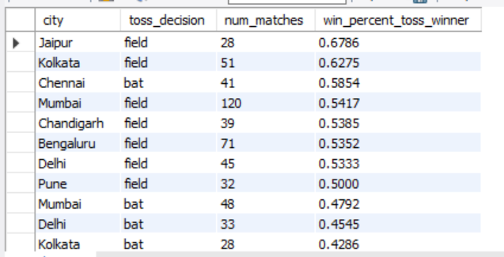

**-- Typical playing 11 breakdown by position**

select case when Playing_Position in ('Wicketkeeper','Wicketkeeper Batter') then 'Wicket Keeper'

when Playing_Position like '%Batter%' then 'Batsman'

when Playing_Position like '%Allrounder%' then 'All Rounder'

else 'Bowler' end as Playing_Position,

sum(ct) as players_in_position,count(distinct match_id) as num_matches,

sum(ct)/count(distinct match_id) as players_in_11

from(

select match_id,Playing_Position,count(*) as ct

from(

select p11.*,md.winner,pk.Playing_Position

from playing_11 p11

left join match_details md

on p11.Match_ID = md.match_id

left join players_info_with_keys pk

on p11.key_cricinfo = pk.key_cricinfo) a

where team = winner

group by 1,2) b

where Playing_Position is not null

group by 1;

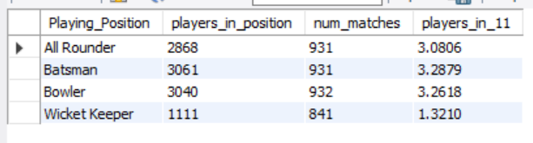

**-- Tight bowling correlation with match outcome**

select season,sum(case when extras_team < other_extras then 1 else 0 end)/count(case when extras_team < other_extras then 1 else 0 end)

as matches_tighter_bowlers_won

from(

select season,match_id,bowling_team,winner,extras_team,

case when lag(extras_team) over (partition by match_id) is null

then lead(extras_team) over (partition by match_id) else lag(extras_team) over (partition by match_id)

end as other_extras

from(

select dl.season,dl.match_id,dl.bowling_team,md.winner,

sum(extras) as extras_team

from deliveries dl

left join match_details md

on dl.match_id = md.match_id

group by 1,2,3,4

order by 1,2,3) a

) b

where bowling_team = winner

group by 1;

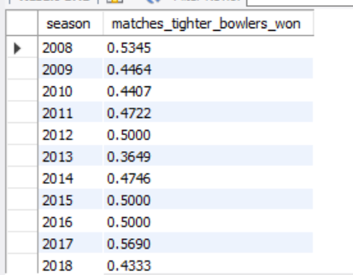

**-- Catches win Matches split by season**

select season,sum(case when field_wick_team > field_wick_others then 1 else 0 end)/count(case when field_wick_team > field_wick_others then 1 else 0 end)

as matches_better_fielders_won

from(

select season,match_id,bowling_team,winner,field_wick_team,

case when lag(field_wick_team) over (partition by match_id) is null

then lead(field_wick_team) over (partition by match_id) else lag(field_wick_team) over (partition by match_id)

end as field_wick_others

from(

select dl.season,dl.match_id,dl.bowling_team,md.winner,

sum(case when wicket_type in ('caught','run out','caught and bowled','stumped') then 1 else 0 end)

as field_wick_team

from deliveries dl

left join match_details md

on dl.match_id = md.match_id

group by 1,2,3,4

order by 1,2,3) a

) b

where bowling_team = winner

group by 1;

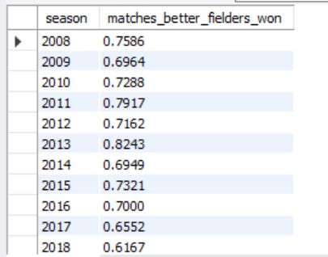

**-- Capturing the Powerplay**

select season,sum(case when runs_conceded < runs_conceded_others then 1 else 0 end)/count(case when runs_conceded < runs_conceded_others then 1 else 0 end)

as matches_big_batters_won,

sum(case when wickets_taken > wickets_taken_others then 1 else 0 end)/count(case when wickets_taken > wickets_taken_others then 1 else 0 end)

as matches_sharp_bowlers_won

from(

select season,match_id,bowling_team,winner,runs_conceded,wickets_taken,

case when lag(runs_conceded) over (partition by match_id) is null

then lead(runs_conceded) over (partition by match_id) else lag(runs_conceded) over (partition by match_id)

end as runs_conceded_others,

case when lag(wickets_taken) over (partition by match_id) is null

then lead(wickets_taken) over (partition by match_id) else lag(wickets_taken) over (partition by match_id)

end as wickets_taken_others

from(

select dl.season,dl.match_id,dl.bowling_team,md.winner,

sum(runs_off_bat+extras) as runs_conceded,

sum(case when wicket_type <> ''then 1 else 0 end) as wickets_taken

from deliveries dl

left join match_details md

on dl.match_id = md.match_id

where dl.ball <6.1

group by 1,2,3,4

order by 1,2,3

) a

) b

where bowling_team = winner

group by 1;

